Supplementary Information
Supplementary Table 1: Repeat tests between the replica and artefact tool sets in support of the Kruskal-Wallis tests performed in the main text. New Kruskal-Wallis tests are presented here that use equal sample sizes between the assemblages. Both assemblages in the 2D samples have 540 tools, while both tool-sets in the 3D analysis have 371. Mann-Whitney U tests are also presented, using both the original samples sizes and the new adjusted equal samples. In all instances shape differences are significant (α = .05).
Mann Whitney-U
Sample | 2D |  | 3D
 | PC1 | PC2 | PC1 | PC2
Original | <.0001 | <.0001 | <.0001 | <.0001
Equal | <.0001 | <.0001 | <.0001 | <.0001
Kruskal-Wallis
Equal | .0002 | <.0001 | <.0001 | <.0001

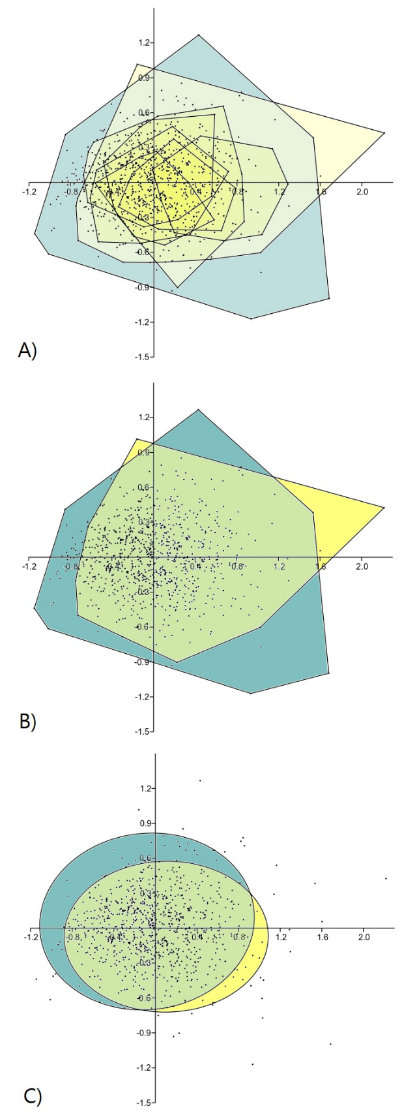
Supplementary Figure 1: Plots detailing the 2D shape space overlap between the replica and artefact handaxes, using only the tool assemblages also used in the 3D analyses. PC1 is plotted against PC2. To produce this data, a new principal component analysis was run using only 2D shape data from this more limited number of tool assemblages. Plot A depicts the shape space of all individual assemblages in the analysis, as highlighted by their independent convex hulls. Plot B illustrates the convex hulls of each grouped sample (replica tools and artefacts). Plot C depicts the 95% confidence ellipse of each grouped sample. Despite the more limited number of artefacts used, similarities in shape space between the two tool types are similar to the 2D analyses performed in the main results sections.

